- Section-02-about
- Change this photo. The tarred road is not a good look for a great safari.
- Next step: Change the photo to this “White_Rhino_Hluhluwe_Umfolozi-683739915.jpg”

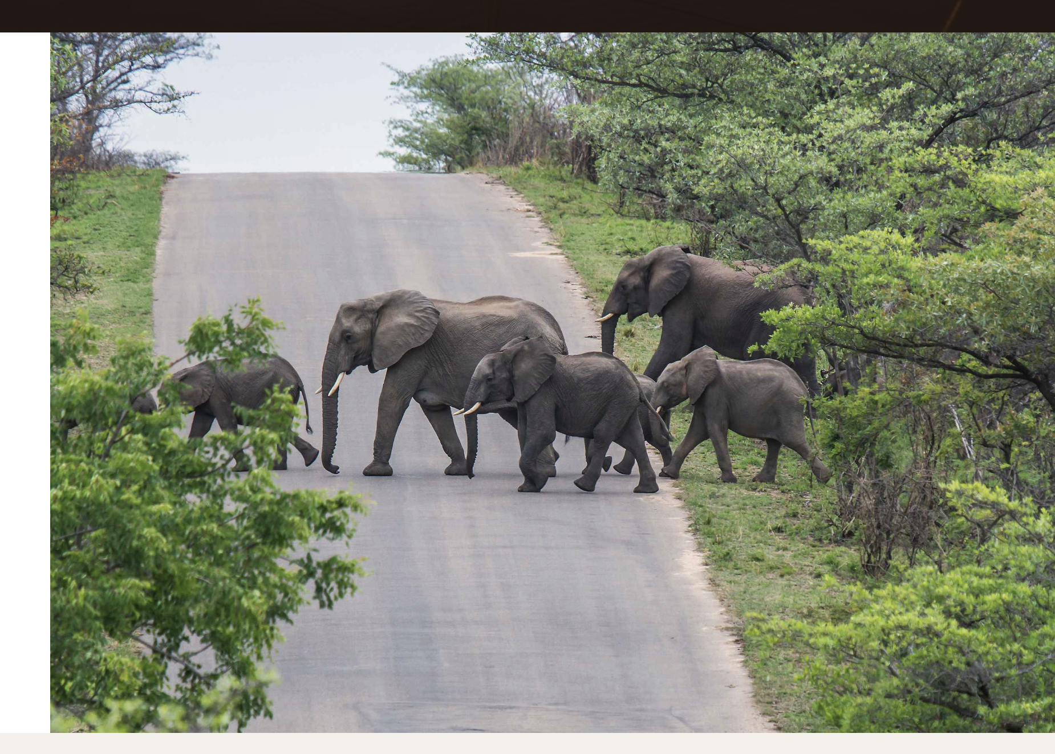

- Section-03-signature-journey
- Change this image below to this one of “ZAV_6901.png”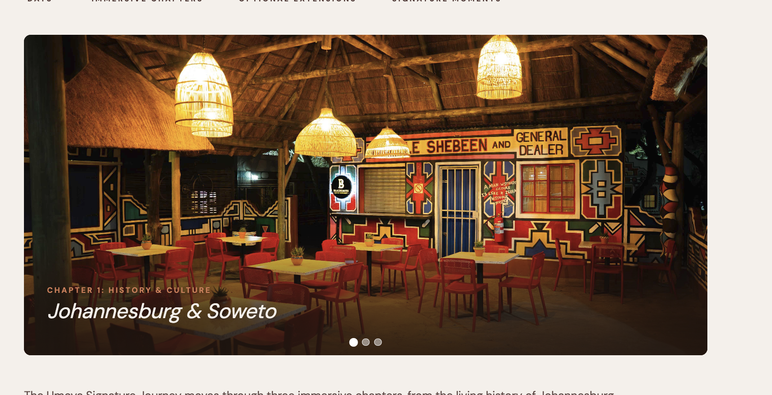

- Section-04-ways-to-travel
- Update photos below to the following:
ZAV_6198.png, ZAV_8994.png, ZAV_8926.png
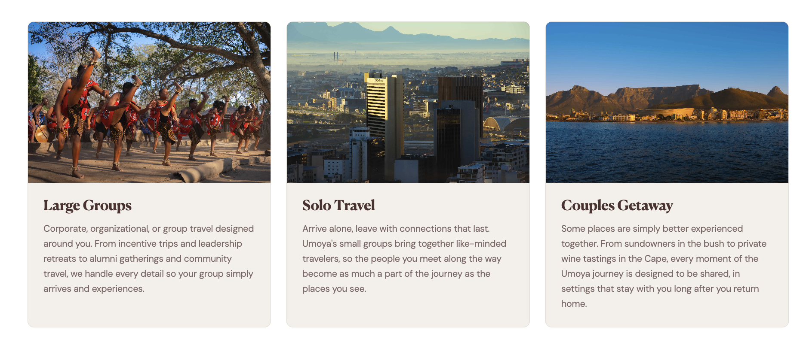

- Section-05-legends
- Could not get very good photos of all of these folks. We will switch and instead use images that describe what the name is associated with

- Lucia: ZAV_6216.png.
- Antionette Sithole: ZAV_6880.png memorial.
- Christo Brand: ZAV_1363.png.
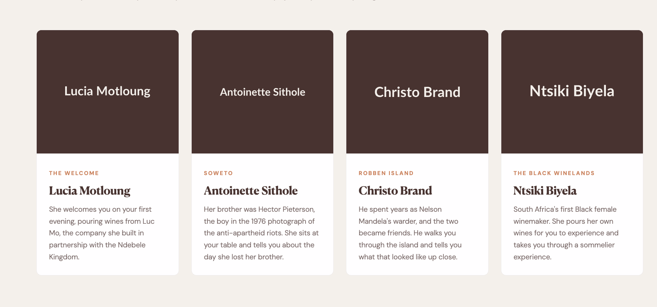
- Ntsiki Bieya: img371169908.jpeg.

- section-01-hero
5. Reduce the height of the hero section so it doesn’t take up a lot of space and leaves some room to view a bit of the next section.

